Seven Microeconomic Questions
Name
Institution
Date

Seven Microeconomic Questions
Question 22
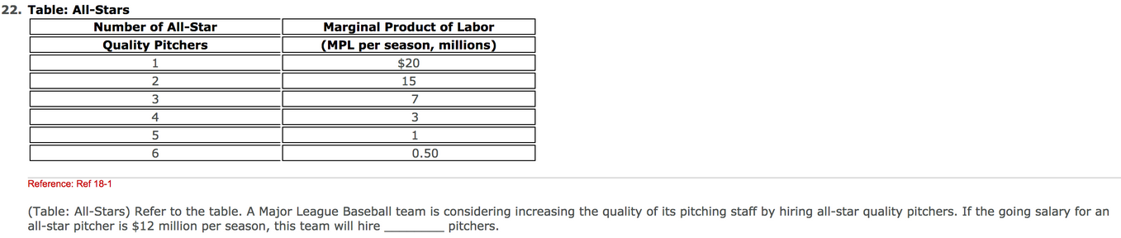
Answer: 2 pitchers
Justification; the marginal product of labor declines as more labor is engaged. Therefore, the firm will continue to hire laborers until the wage rate is less than the Marginal Product of Labor (Wage Rate< MPL). The All-Star company should hire a maximum of two pitchers because the MPL for the two laborers (15) is greater than the current salary of $12 million per season. Consequently, an additional third pitcher result in a lesser MPL of 7, which equates to a loss for the All-Star company.
Question 26

Answer: All jobs have the same danger lever
Justification: Human-capital labor market issues relate to factors that enhances the efficiencies and supply of the laborers in an economy. Therefore, a college education, government retraining program, and on-the-job skills enhances both the effectiveness as well as the quantity of work forces in an economy.
Question 27

Answer: Decrease their Demand for Labor
Justification: The demand and supply of labor in an economy is dependent on the intersection of the two market forces. A fall in the price of the output in an industry implies loss making, which tend to decrease the overall demand for the labor because of the possible layoff of employment.
Question 31

Answers:
PART 1: The event reduces the demand for the high-tech job in the United States (Demand 2)
PART 2: The event increases the supply for the high-tech job in the United States and reduces the wage-rate in the long-term (Supply 3)
Question 32

Supply Curve
Price/Cost

Supply Social Value (S2)

Equilibrium Price (PM)
Efficient Equilibrium Price (Pe)
Demand Curve (S1)

Demand Social Value (S2)
Efficient Equilibrium Qnty (QE)
(QM)
Quantity of Home Improvement

Question 33
Price
Marginal Cost
Economic Profit
Dead-Weight Loss
Average Total Cost
P*
Cost

Demand=Price
Qso
Q*
Quantity
0
Marginal Revenue

Question 34
Pretzel

